FULL NAME : HAMTIG, MAE ANN B

COURSE NAME: BACHELOR OF SCIENCE IN INFORMATION TECHNOLOGY

COURSE CODE: IT263

**TOPIC TITLE: INTRODUCTION TO PHP**

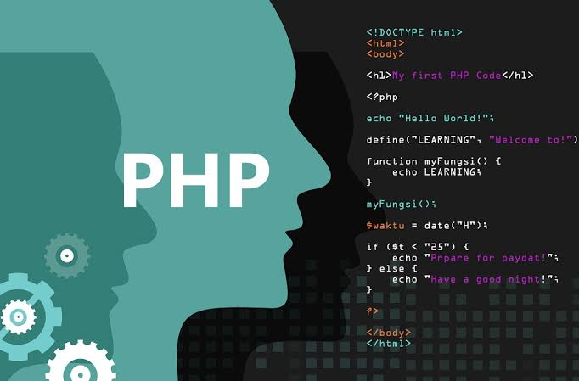 **Introduction**

PHP was written in the C programming language by Rasmus Lerdorf in 1994 for use in monitoring his online resume and related personal information. For this reason, PHP originally stood for "Personal Home Page". Lerdorf combined PHP with his own Form Interpreter, releasing the combination publicly as PHP/FI (generally referred to as PHP 2.0) on June 8, 1995. Two programmers, Zeev Suraski and Andi Gutmans, rebuilt PHP's core, releasing the updated result as PHP/FI 2 in 1997. The acronym was formally changed to PHP: HyperText Preprocessor, at this time. In 1998, PHP 3 was released, which was the first widely used version. PHP 4 was released in May 2000, with a new core, known as the Zend Engine 1.0. PHP 4 featured improved speed and reliability over PHP 3. In terms of features, PHP 4 added references, the Boolean type, COM support on Windows, output buffering, many new array functions, expanded object-oriented programming, inclusion of the PCRE library, and more. Maintenance releases of PHP 4 are still available, primarily for security updates. PHP 5 was released in July 2004, with the updated Zend Engine 2.0. PHP 6 has been in development since October of 2006. The most significant change will be native support for Unicode. Unpopular, deprecated features such as Magic Quotes, register_globals, safe_mode,

and the HTTP_*_VARS variables will disappear in PHP 6. Although PHP is still primarily used for server-side generation of Web pages, it can also be used to perform command-line scripting or to create graphical applications with the help of GTK+.

**DEFINITION**

PHP is a server side scripting language that is used to develop Static websites or Dynamic websites or Web applications. PHP code can be interspersed with HTML, making it simple to generate dynamic pieces of Web pages on the fly. As a scripting language, PHP code requires the presence of the PHP processor. It is normally run in plain-text scripts that will only run on PHP-enabled computers. PHP takes most of its syntax from C, Java, and Perl. It is an open source technology and runs on most operating systems and with most Web servers. PHP stands for Hypertext Pre-processor, that earlier stood for Personal Home Pages. PHP scripts can only be interpreted on a server that has PHP installed. The client computers accessing the PHP scripts require a web browser only. A PHP file contains PHP tags and ends with the extension ".php".

**SUMMARY**

PHP stands for Hypertext pre-processor and it was written in the C programming language by Rasmus Lerdorf in 1994 for use in monitoring his online resume and related personal information. PHP is a server side scripting language. This means that it is executed on the server. The client applications do not need to have PHP installed. PHP files are saved with the ".php" file extension, and the PHP development code is enclosed in tags. PHP is open source and cross platform.